Our one-stop centers are not just for job-seekers

NCWorks Career Centers are also equipped to help employers like you find, train, and retain the qualified employees you need to succeed.
There are 80+ Career Centers located across the state, and each center provides services to help local businesses, including the following:
- Job applicant screening and qualified candidate referrals
- Valuable and up-to-date labor market facts and projections, such as wages
- Information on tax credits for hiring particular groups of workers
- Space to conduct job interviews
- Help arranging job fairs
- Layoff/closure prevention services for employers
- Information about Federal Bonding (insurance for hiring at-risk workers)
These services are offered at no cost to your business.

NCWorks Online
The state’s official job search website, NCWorks Online, gives employers the ability to search for candidates based on their skills, work experience, and resumes. Businesses can also take advantage of real-time information on the labor market, contact and save their favorite candidates, and find local training programs for their workers.  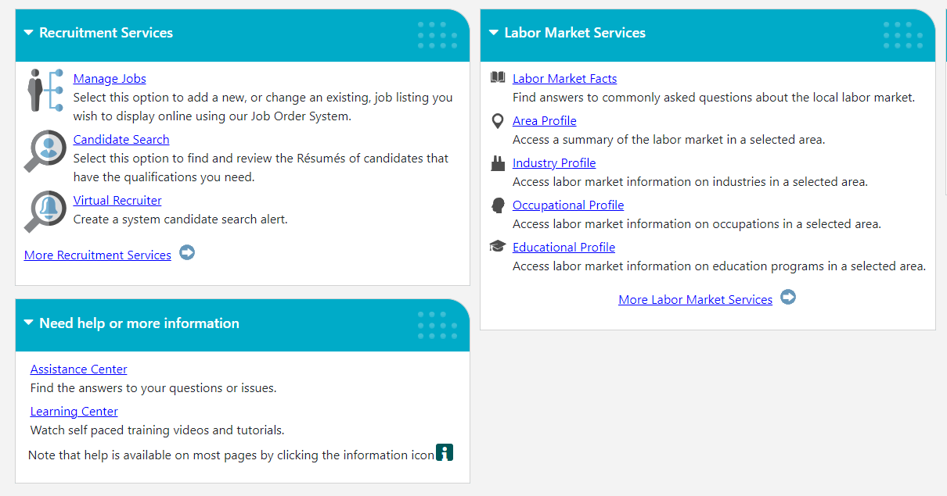 |  | 0.0 mi
Business Edge is a series of layoff aversion strategies and activities designed to help North Carolina employers prevent or minimize job losses. Through Business Edge, workforce partners collaborate with business leaders to assess the needs of, and options for, "at-risk" firms, and to deliver services that address those needs. Email: BusinessServices@ncworks.gov

